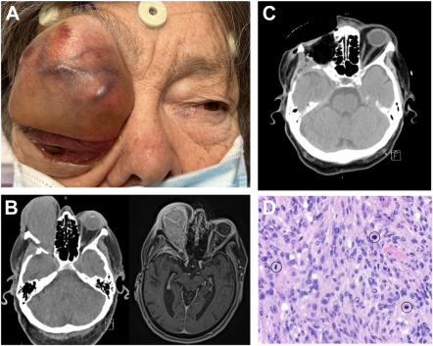

An 83-year-old woman presented with 2 months of progressive painful vision loss of the right eye. She had a previous World HealthOrganization (WHO) grade 1 right sphenoid wing meningioma, status postsurgical resection 2 years prior. Examination revealed a largeorbital tumor and a nonformed, inferolaterally displaced globe (A). Imaging revealed a 7.5 cm 3.8 cm 4.2 cm intraorbital mass withintracranial extension along the temporal lobe and cavernous sinus (B). A right cranio-orbital craniotomy, orbital exenteration, and resectionof the anterior/middle fossa tumor was performed (C). Histology revealed a WHO grade 3, anaplastic meningioma with frequent mitoticactivity (D, circled). Based on the provided images and clinical description please make an ophthalmic diagnosis for this patient. And output the diagnostic conclusions only.

**The ophthalmic diagnosis for this patient is a WHO grade 3 anaplastic meningioma.**